14.1.4 Editors - Movie Clip Editor - Header - Tracking Mode - Clip Submode - Clip Menu
Clip Menu 1
Open Clip 1
Prefetch Frames 1
Reload Clip 1

Clip Menu

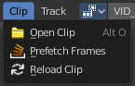
Open Clip
Opens a Image Sequence or a movie clip.

Prefetch Frames
Prefetch frames from disk for faster playback and/or tracking.

Reload Clip
Reloads the movie clip.

